XCRAM
Use Case Specification

Submitted to:

Asst. Prof. Ma. Rowena C. Solamo
Faculty Member
Department of Computer Science
College of Engineering
University of the Philippines, Diliman

Submitted by:
Agluba, Gerry P.
Go, Sharleen Joy Y.
Silverio, Robelle C.

In partial fulfillment of academic requirements for the course

CS 191 Software Engineering I of the

1st Semester, AY 2016-2017

System: Task Scheduling System Page: 1
Version: 1.0 Group: TaskOverflow
Unique Reference:

The documents are stored in the https://github.com/sharleengo/XCRAM

https://github.com/sharleengo/XCRAM/blob/master/02-Requirements-Engineering/2.3%20-%20View%20Saved%20Schedule.pdf

Document Purpose:

The purpose of this document is to present the use case specification of ‘View Saved Schedule’ use case.

Target Audience:

Evaluators and users.

Revision Control

History Revision:
Revision | Person | Version | Modification
Date | Responsible | Number
09/29/16 | Robelle Silverio | 1.0 | Specified purpose, target audience, use case
 |  |  | name, use case precondition, flow of events
 |  |  | (scenarios along with its description). Added
 |  |  | activity diagram.
9/29/16 | Sharleen Joy Go | 1.1 | Added use case description.

System: Task Scheduling System Page: 2
Version: 1.0 Group: TaskOverflow

Use-Case Name:

Description:

Use-Case 2.3 View Saved Schedule

This use-case will allow the User to view any of his saved schedules. The saved schedules' names would be listed and the User may choose to view any of them. The chosen schedule will be displayed in the same manner as the View Current Schedule use-case displays the current schedule.

Preconditions:

Flow of Events:

At least one saved task schedule is existing.

Scenario Name |  | Description
Scenario 1 (Basic Flow) | 1. The User chose the option of viewing saved schedule.
User chose to view saved | 2. A list of schedule saved will be shown, represented by the name of a
schedule and hides the saved | particular schedule.
schedule after viewing it | 3.User will now decide which among of the listed saved schedule to
 | display.
 | 4. | The entire schedule is shown.
 | 5. | Each block could be a block with task title (a task for that day) or a free
 | task block (no task assigned) which corresponds with a specific time range.
 | 6. | Uses military time.
 | 7. | One day means 00:00 to 23:59.
 | 8. | When User decided to hide saved schedule, then schedule for the entire
 | day is no longer displayed.
Scenario 2 | 1. The User chose the option of viewing saved schedule.
User chose to view saved | 2. A list of schedule saved will be shown, represented by the name of a
schedule and didn’t hide the | particular schedule.
saved schedule after viewing it | 3.User will now decide which among of the listed saved schedule to
 | display.
 | 4. | The entire schedule is shown.
 | 5. | Each block could be a block with task title (a task for that day) or a free
 | task block (no task assigned) which corresponds with a specific time range.
 | 6. | Uses military time.
 | 7. | One day means 00:00 to 23:59.
 | 8. | When User decided not to hide saved schedule, then schedule for the
 | entire day is still displayed.

System: Task Scheduling System Page: 3
Version: 1.0 Group: TaskOverflow
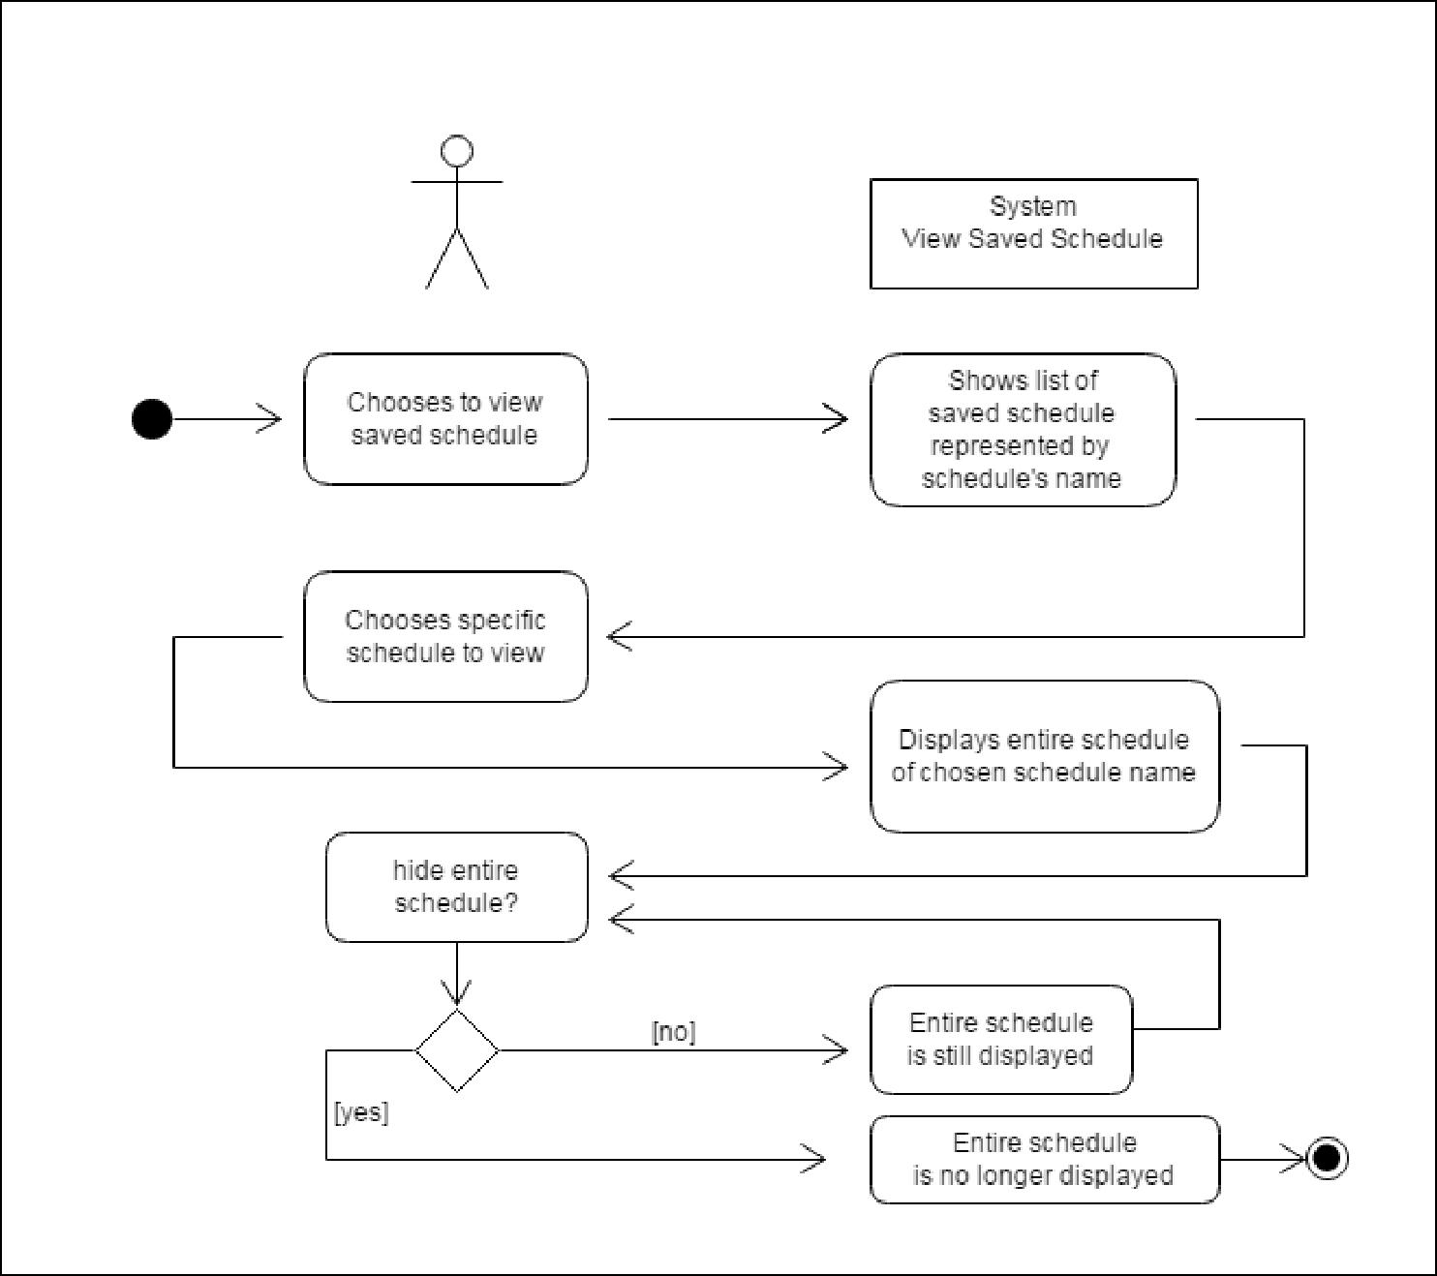

user

Activity Diagram of the flow of events:

System: Task Scheduling System Page: 4
Version: 1.0 Group: TaskOverflow
Post Condition: None

Relationship: None

Special Requirements: None

System: Task Scheduling System Page: 5
Version: 1.0 Group:TaskOverflow

